ASSIGNMENT NO.9: Data Retrieval, Functions, and Joins in MySQL
Questions:
Q1) Create a MySQL database named CollegeDB and create two tables: OnlineEnrollment and OfflineEnrollment.
OnlineEnrollment Table
Column Name | Data Type | Constraint
StudentID | INT | PRIMARY KEY
StudentName | VARCHAR(50) | NOT NULL
Course | VARCHAR(30)
City | VARCHAR(30)
Marks | INT
OfflineEnrollment Table
Column Name | Data Type | Constraint
StudentID | INT | PRIMARY KEY
StudentName | VARCHAR(50) | NOT NULL
Course | VARCHAR(30)
Column Name | Data Type | Constraint
City | VARCHAR(30)
Marks | INT

QUERY:
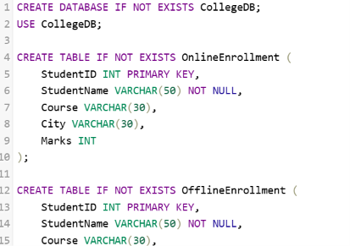
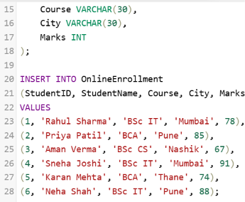
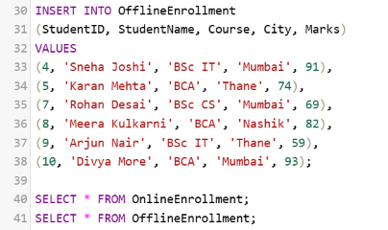

OUTPUT:
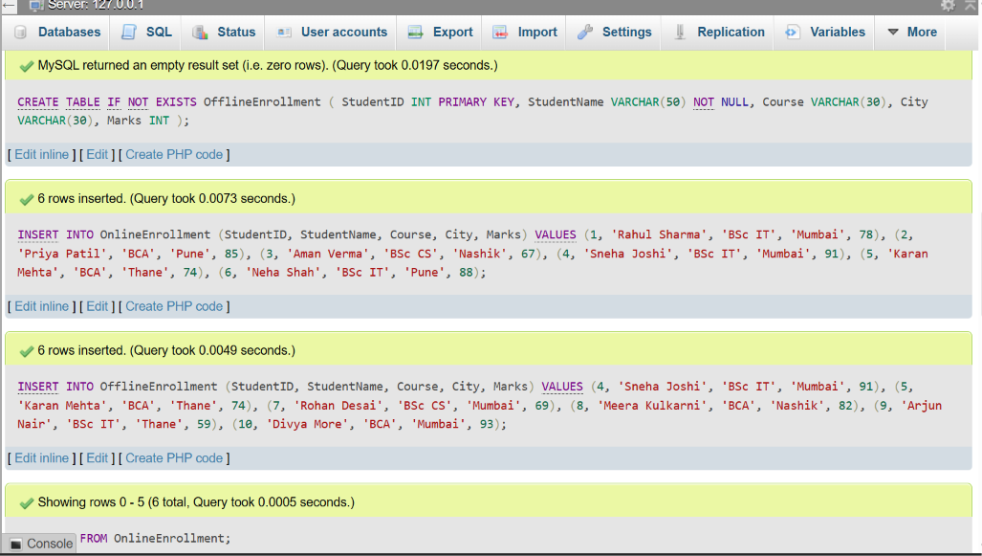
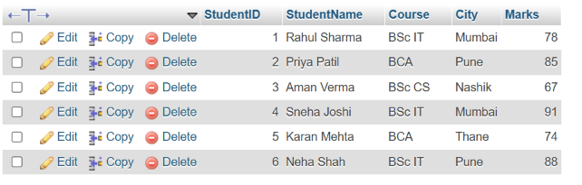



2) Write a MySQL query using UNION to display all unique students from both OnlineEnrollment and OfflineEnrollment.
The output should contain:
Column
StudentID
StudentName
Course
City
Marks

QUERY:
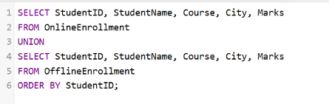
OUTPUT:
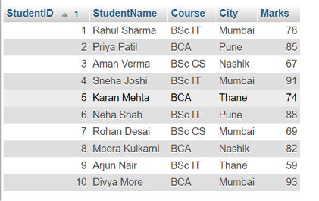

Q3) Write a MySQL query using UNION ALL to combine records from both tables while keeping duplicate records.
Also write one line explaining the difference between UNION and UNION ALL.

QUERY:
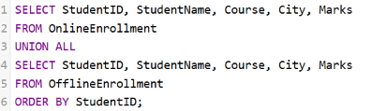

OUTPUT:
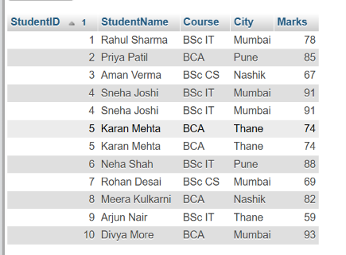

Q4) Write a MySQL query using INTERSECT to display students who are present in both online and offline enrollment tables.
The output should contain:
Column
StudentID
StudentName
Course
City
Marks

QUERY:
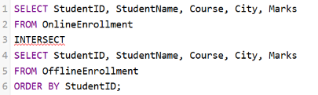

OUTPUT:
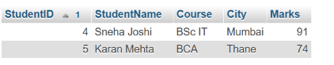

Q5) Write a MySQL query using EXCEPT to display students who are present only in the online enrollment table.
The output should contain:
Column
StudentID
StudentName
Course
City
Marks

QUERY:
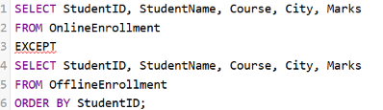
OUTPUT:
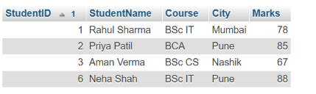

Q6) Write a MySQL query to display high-scoring students from both tables.
The query should:
Requirement
Select students with marks greater than or equal to 85
Use UNION to combine both tables
Display StudentID, StudentName, Course, and Marks
Sort the final output by Marks in descending order

QUERY:
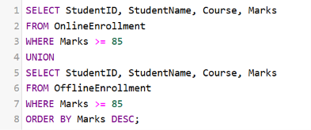

OUTPUT:
